When a County Has More Kids, Transportation Barriers Rise
Date: 2026-02-23
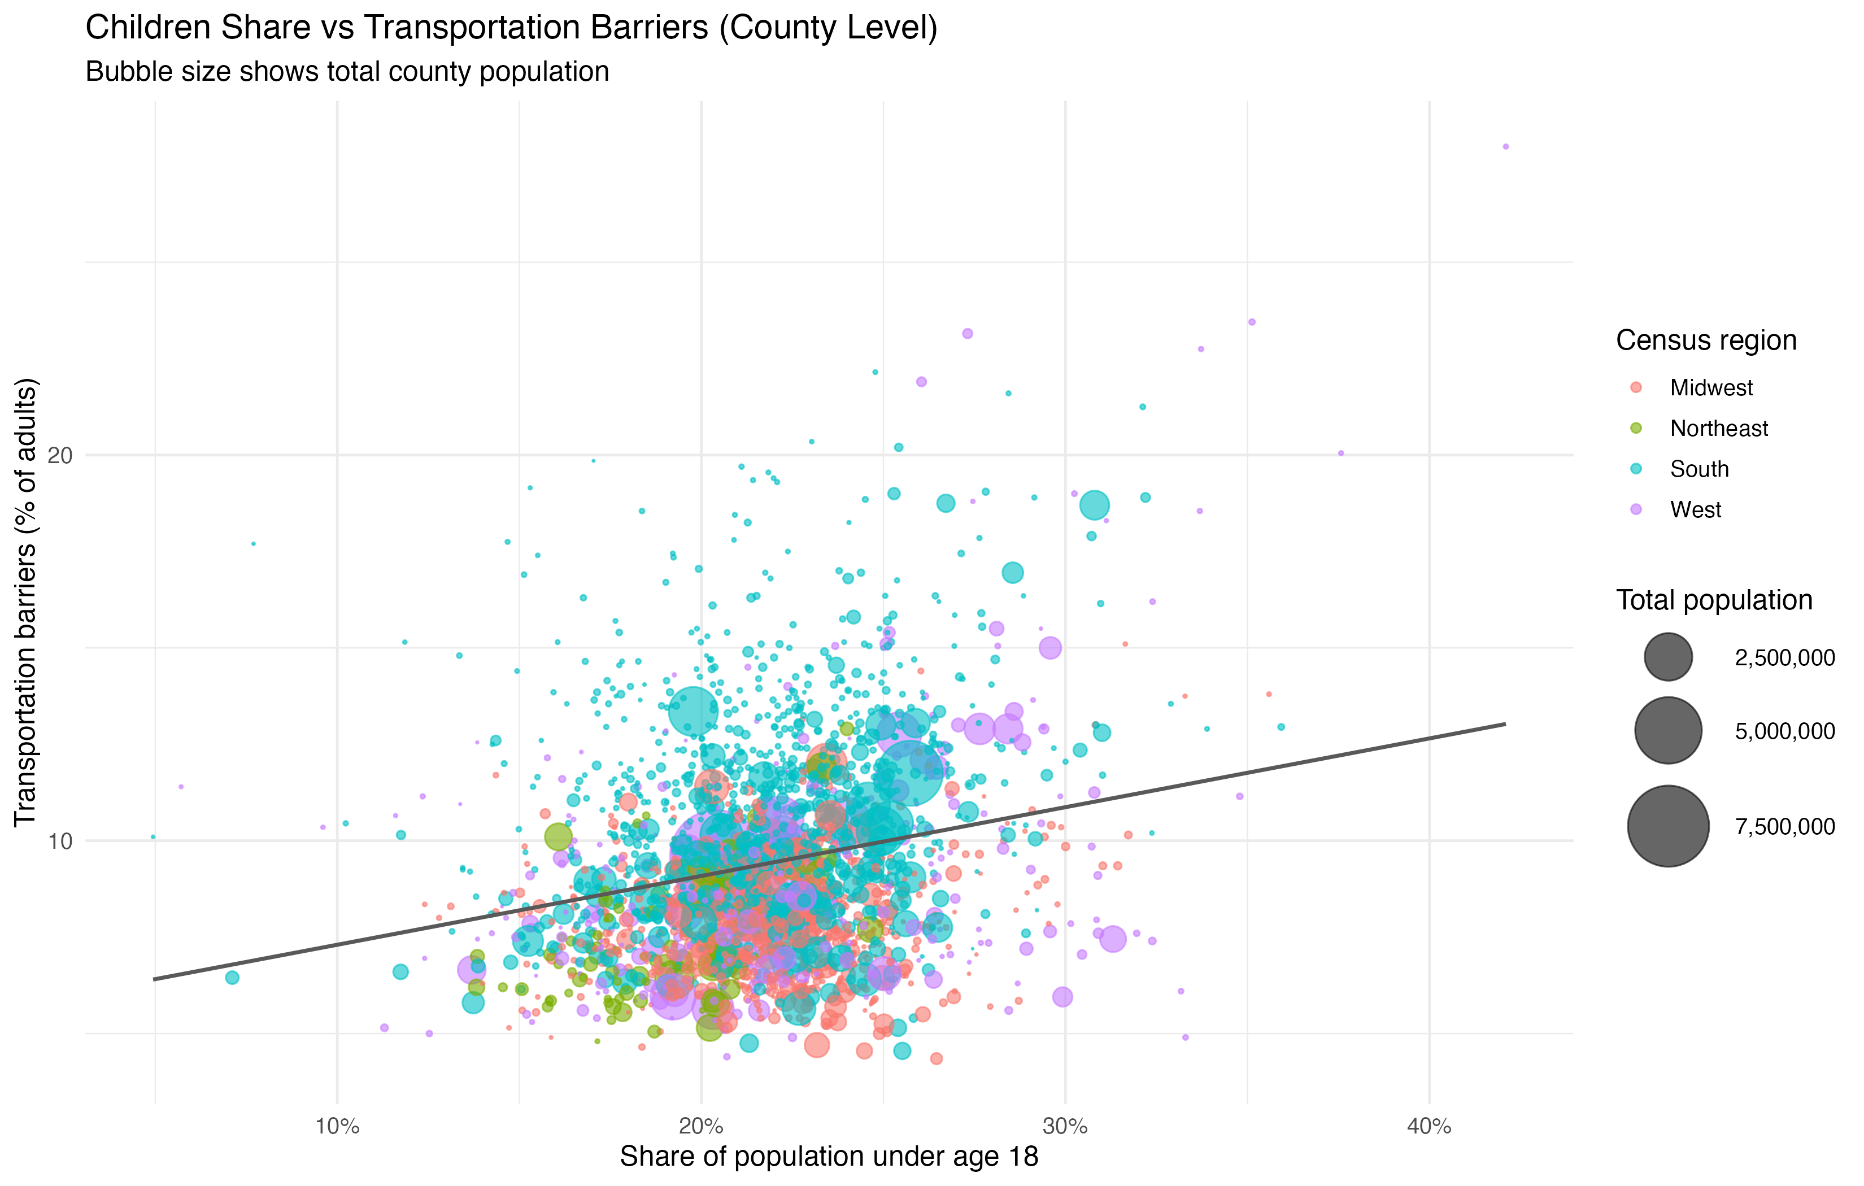
Centers for Disease Control and Prevention. PLACES: Local Data for Better Health – County Data. 2025. CDC PLACES. Accessed February 24, 2026. https://data.cdc.gov/500-Cities-Places/PLACES-Local-Data-for-Better-Health-County-Data-20/fu4u-a9bh/about_data.
In counties where families make up a larger share of the population, transportation challenges are more common.

What the Numbers Mean in Real Terms
Across 2,417 counties, we find:
- If the share of children increases by 10 percentage points (for example, from 20% of the population to 30%),
- Then the share of adults reporting transportation barriers increases by about 2 percentage points.
In Utah County, with roughly half a million adults, that same 10-point difference in the share of children would be associated with nearly 10,000 additional adults facing transportation barriers.
That’s more than half the seating capacity of the Marriott Center filled with adults who struggle to get to work, medical appointments, school drop-offs, and other daily responsibilities.
The pattern is statistically precise: the true increase is very likely between about 1.5 and 2.1 percentage points.

Where the Pattern Is Strongest
The relationship is not uniform across the country.
It is strongest in:
- Northeast
- West
More moderate in:
- South
Weakest in:
- Midwest
In other words, in some regions, counties with more children see transportation barriers rise sharply; in others, the increase is present but more modest.

Why This Matters
Children do not drive. Their ability to participate in daily life depends on adults, safe environments, and transportation systems that make movement possible.
When a county has a higher concentration of children, the overall pattern of travel shifts. More trips are shared, chained together, or coordinated across family members. Daily life involves getting multiple people to multiple places — reliably and safely.
If adults in those same counties are more likely to face transportation barriers, children are affected as well. Their access to opportunity, independence, and safety is shaped by whether the transportation system works for the households they depend on.
The data suggest that in places with more families, mobility systems may be under greater pressure, with implications not just for adult access, but for how children move through and experience their communities.

What This Does Not Show
- This does not prove that having more children causes transportation barriers.
- The analysis is based on county-level averages and individual experiences vary.
- Other local factors, including land use, transit access, income levels, also shape outcomes.

AI Disclosure
This repository used AI assistance (OpenAI Codex) to help draft analysis code, generate plot variations, and edit documentation.
Results and interpretations were reviewed by the project author. The reviewer is not a statistician, so findings should be treated as exploratory and independently validated before publication or policy use.

